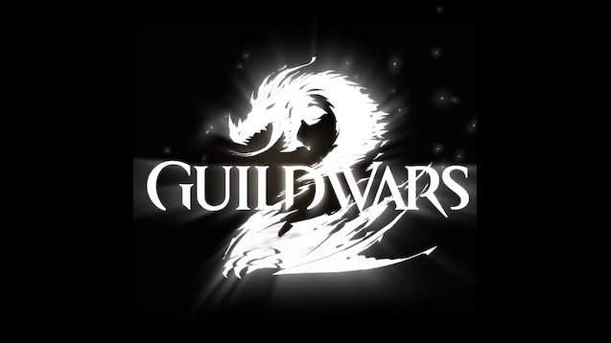

GUILDWARS 2 Drizzlewood Guide

All usefull things you need to know to get further in the game

By Artemisu San AKA Artemis

Exodus/z of the elder dragons/z[GODS]   EU based

Drizzlewood Coast

We need to clear + capture all camps and push northward in two lanes. Increase morale at each camp to push forward by fixing buildings with War Supplies, doing events in the area, killing Dominion mobs, clicking speakers and shrubs. Capture Leadfoot Village (Vishen) and Lighthouse Point (Devourer Tank) and increase morale to trigger final escort. Escort will not trigger if there are camps under attack from Dominion forces.

At Wolf’s Crossing, Vishen and the Devourer tank will spawn and fight together. Kill them within 1 min of each other and finally kill Nicabar's Copter which charzookas.

Camps

* Each camp is captured in the same way.
* Escort Imperator to the Dominion camp (red) > Clear mobs + structures > Kill champion > Capture square > Loot Capture box (disappears in 5 mins)
* Use War Supplies to gain special action (EMP) from the United Legions Waystations to destroy buildings very quickly.
* Increase morale at each camp to push forward by fixing buildings with War Supplies, doing events in the area, killing Dominion mobs, clicking speakers and shrubs, feeding the hungry, quenching the thirsty, mending the hurt, etc.

Travelling

Click on the blue circles in captured blue camps on the map to get around easily using 5 war supplies. Note: YOU MUST BE GROUNDED TO USE THIS. It does not trigger if you are in the air. Griffon is a great mount to use here after you TP to get to any location on the map quickly. You can also respawn via airdrop as well if you are dead.

Vishen, Ranoah and Nicabar

Leadfoot Village

* Vishen - Creates clones of herself and will teleport every 25% to a random location. The real boss will always have a blue cc bar. Click on her HP bar in the event info box to find the real boss quickly. In order to damage her, the cc bar must be broken by normal means or by using the EMP.

Lighthouse Point:

* Ranoah's Devourer - Will drop bombs every  25% (marked by whitish blue circles on the ground) and players should pick it up to break the tank cc bar quickly.

Wolf's Crossing:

* Both bosses need to be killed together about the same time. When one of the bosses dies, a 1 minute timer will begin and the other boss must die before time is up. Failure to do so will result in the first boss respawning at 10% health.
* Vishen - She will teleport to one of the three specific spots to snipe people up on the cliffs near the bridge. Take Kasmeer’s mesmer portals to find the real one and break her cc bar to damage her. You can find the correct Vishen by locating the copter - the location at which the copter hovers is also Vishen's correct location. (marked by orange skull symbol)
* Ranoah’s Devourer - Will be on the ground. As a comm, it is helpful to put a marker on it for visibility. Avoid the pools of death and constant bombing.
* Nicabar's Copter - Can be damaged after Vishen and Tank are defeated. Must be taken down with the "Charzooka" equipped weapon found near the bridge.

Dominion Keeper - Champ Train

As soon as the  main meta-bosses have been killed, 10 Charr defector champs will spawn at 10 specific locations on the map 1 at a time in a random order. Fastest way to get to these champs is to teleport back to camp (via blue circle on map) and then glide/griffon/skyscale over. There is a 15 minute window before the champs disappear and the map resets back to the beginning. You need 40 keys to open all the chests from the champs.

Participation

Yes, it is back from the HoT metas. As you do the meta on this map, you will receive rewards every 10 minutes based on which blue camp(s) are captured and your participation percentage. Higher participation percentage will reward higher quality chests from each of the camps. Events around the map will award participation depending on your reward tier.

(Gold = 10% || Silver = 7.5% || Bronze = 5%)

Commander Guide

Option #1 - 2 commanders

* Commander #1 capture the camps west: Vloxen Mine → Fort Defiance → Leadfoot Village. Escort NPC eastward to Wolf's Crossing bridge from Leadfoot Village.
* Commander #2 capture the camps east: Petraj Overlook → Port Cascadia → Lighthouse Point. Escort NPC westward to Wolf's Crossing bridge from Lighthouse Point.

Option #2 - 1 commander with lieutenant

* Same strategy as Option #1 but the lieutenant will take one of the lanes. Agree with the lieutenant which markers are yours and which are theirs. Alt + 1-4 for Comm and Alt + 5-8 for Lieutenant is my recommendation

Option #3 - 1 commander

* Commander will bounce between each side to balance out the progression of camps on the map to maximize rewards.
* Use Group 1 as people fill the squads so they can be placed in other groups as necessary. Put yourself in Group 4 so others can identify and join you easily.
* Progression
  + Group 2 - Mines > Fort Defiance > Leadfoot > West Escort
  + Group 3 - Petraj > Port Cascadia > Lighthouse > East Escort